Odyssey Registration Configuration

Version 1.0

Started 10/18/2011

Initially written by Robert Bernstein

Contents

Odyssey Web Site Configuration 2

Overall Configuration Information 2

Web Deploy Publishing Information 2

Odyssey Registration Configuration 2

Setting Up the Configuration Environment 2

Accessing the SQL Server Database 2

Configuring Registration Open and Close Dates and Times 3

Test Environment (vs. Production Environment) 4

Webmaster E-mail Account 5

Coaches Training Registration 5

View the Current List of Problems 5

Edit the List of Problems 6

Changing the Amount Charged for Coaches Training 6

Adding or Removing References to the Coaches’ Handbook 7

Displaying whether Coordinators Pay the Coaches Training Registration Fee 7

Accessing Coaches Training Registration 7

Judges Registration 7

Accessing Judges Registration 7

Tournament Registration 7

Accessing Tournament Registration 7

# Odyssey Web Site Configuration

## Overall Configuration Information

As of 09/15/2013

|  |  |
| --- | --- |
| Hosting Company: | <http://www.winhost.com> |
| Domain name: | novanorth.org |
| Plan: | Max |
| Billing Period: | Monthly |
| Web Server: | Windows 2008 with IIS 7.0 |
| Server Name: | w04 |
| Secondary Web URL: | vaodysse.w04.wh-2.com |
| Path to root: | E:\web\vaodysse\ |
| FTP: | [ftp.novanorth.org](ftp://ftp.novanorth.org) |
| Secondary FTP: | [ftp.w04.wh-2.com](ftp://ftp.w04.wh-2.com) |
| FTP Username: | vaodysse |
| IIS Manager Login: | [Same as FTP Login [more info]](https://cp.winhost.com/sites/iis.aspx) |
| Site IP Address: | 96.31.35.44 |
| SMTP/POP/IMAP: | mail.novanorth.org |

## Web Deploy Publishing Information

|  |  |
| --- | --- |
| Server / Service URL: | https://w04.winhost.com:8172/MsDeploy.axd |
| Site Name: | novanorth.org |
| Username: | Vaodysse |
| Password: | Same as FTP password |

## Fixing WordPress Theme Problems

If the WordPress theme used by the web site is broken, you can delete or move the directory in which the theme is currently installed so that you may reinstall a fresh copy. To do so, you need to install an FTP client on your computer. This includes programs such as CuteFTP, FileZilla, and FTP Explorer. You may wish to see the link below for configuring these programs.

<http://support.winhost.com/KB/c241/ftp-program-configuration.aspx>

For our site, you need to use the following FTP settings:

|  |  |
| --- | --- |
| FTP Site | [ftp.novanorth.org](ftp://ftp.novanorth.org) |
| FTP Port (FTPS Protocol, Explicit SSL) | 21 |
| Username: | Vaodysse |
| Full URL (use instead of above information) | ftps://vaodysse@ftp.novanorth.org/ |

You should also navigate to the WordPress Themes page by logging in as the administrator and connecting to the Themes page. You can do this by logging in at:

<http://www.novanorth.org/wp/wp-admin/>

and navigating to Appearance / Themes or by connecting directly to this page:

<http://www.novanorth.org/wp/wp-admin/themes.php>

To rename the folder containing the current theme, e.g. “Graphene”, return to your FTP client and navigate to the following folder:

/wp/wp-content/themes/graphene

You may also reference this folder using its full path in some FTP clients:

ftps://vaodysse@ftp.novanorth.org/wp/wp-content/themes/grapheme

I was going to just rename the folder from “graphene” to “graphene.old” so that WordPress would no longer find it. My hope was that by doing so, WordPress would not recognize the theme and would let me reinstall “Graphene”. However, refreshing the Themes web page still showed the theme as installed and located in the “graphene.old” folder. So, I moved it up a folder level to the /wp/wp-content directory. Now you can return to the WordPress Themes web page, refresh the page to ensure that “Graphene” is no longer installed. Then click on the “Install Themes” tab at the top of the page. Enter “Graphene” in the Search textbox and click the “Install Now” link. Once the theme has been installed, click the Activate link.

The theme should now be installed correctly. You may use your FTP client to delete the old, moved “graphene" directory.

# Odyssey Registration Configuration

## Setting Up the Configuration Environment

### Accessing the SQL Server Database

Please keep in mind that changes you make to the SQL Server database are immediately reflected in the registration pages.

In order to access the SQL Server database used by the Odyssey Registration System, you will need to download SQL Server Management Studio (SSMS) Express. There may eventually be a number of administration web pages so you don't have to use SSMS directly, but for the time being, this is the best way to edit the registration settings, run queries against the data, etc.

Download SSMS at:

* <http://www.microsoft.com/download/en/details.aspx?id=22985>

You will want to download the x64 version if you are running 64-bit Windows; otherwise, download the x86 version. If you're not sure which one you're running, see here:

* <http://windows.microsoft.com/en-US/windows7/32-bit-and-64-bit-Windows-frequently-asked-questions>

There are a number of prerequisites listed on the page that you may need to install as well.

When you have SSMS installed, you can connect to the DB with the following information:

* From the File menu, select Connect Object Explorer.

|  |  |
| --- | --- |
| Server Name: | s06.winhost.com |
| Database Name: | DB_12824_registration |
| Authentication: | SQL Server Authentication |
| Login: | DB_12824_registration_user |
| Password: | (Available separately) |

If all goes well, you should see the following:

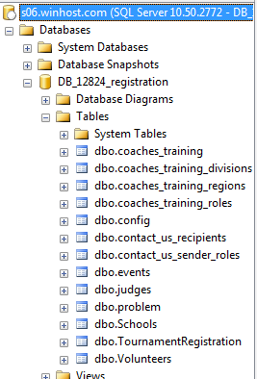

### Configuring Registration Open and Close Dates and Times

You then want to right-click on the dbo.config table and select "Edit Top 200 Rows". It should look like the following:

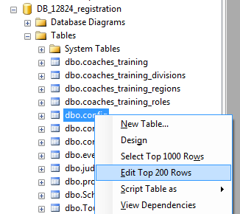

If you look at ID 59 in the results, you will see that I have set it as follows:



Note that the ID values are not important, so don’t worry about their values or their order.

So, since I am writing this on October 18th, 2011, Coaches Training Registration is now open. If you want users to be notified that “Coaches Training Registration is coming soon,” then set the Value to be a date/time after the current date/time.

If you look at ID 61 you will see (as below) that it closes on 11/11/2011 just before midnight, which is the night before the event. You may want to change this to an earlier date.



To see who has already registered, right-click on the dbo.coaches_training table and select "Select Top 1000 Rows." The results will be displayed in the bottom half of the window.

## Test Environment (vs. Production Environment)

There is also a database set up for testing the registration systems. Connect to the database with SSMS using the settings below.

Make sure you are making changes to the correct database; if you change the production database by accident, production users will immediately see those changes during their registrations.

|  |  |
| --- | --- |
| Server Name: | s06.winhost.com |
| Database Name: | DB_12824_test |
| Authentication: | SQL Server Authentication |
| Login: | DB_12824_test_user |
| Password: | (Available separately) |

The files associated with this test database are installed in /vaodysse/test (via FTP).

Here are the links to the test registration pages:

* <http://novanorth.org/test/CoachesTrainingRegistration>
* <http://novanorth.org/test/JudgesRegistration>
* <http://novanorth.org/test/TournamentRegistration>

## Webmaster E-mail Account

The [webmaster@novanorth.org](mailto:webmaster@novanorth.org) account is key to enabling both our WordPress website and our registration system to send e-mails on behalf of the webmaster. It must not be an alias and must be an account in order to authenticate to our SMTP server for outgoing mail. Please make sure not to change this account to an alias.

There is currently a [webmasters@novanorth.org](mailto:webmasters@novanorth.org) alias, i.e. plural, that is configured to forward to multiple e-mail accounts. Also, any mail sent to [webmaster@novanorth.org](mailto:webmaster@novanorth.org) is automatically forwarded to the webmasters alias and then deleted from the server.

The config table in the database contains three fields that enable the registration systems (i.e. Coaches Training, Judges, and Tournament Registration) to send e-mail messages to users. They are:

* WebmasterEmail
* WebmasterEmailPassword
* EmailServer

Their values should look similar to the following:

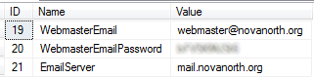

Note that if you change the WebmasterEmail to a different value, e-mails will not automatically get sent to the [webmasters@novanorth.org](mailto:webmasters@novanorth.org) alias, as described above. The new e-mail address would need to be configured in the Hosting company’s control panel to forward mail to this alias.

## Coaches Training Registration

### View the Current List of Problems

To display the current list of problem names provided to the user during registration, right-click on the “dbo.problem” table in SQL Server Management Studio (SSMS) and choose “Select Top 1000 Rows”. It should look like the following:

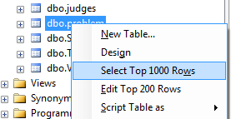

### Edit the List of Problems

To edit the current list of problem names provided to the user during registration, right-click on the “dbo.problem” table in SQL Server Management Studio (SSMS) and choose “Edit Top 200 Rows”. It should look like the following:

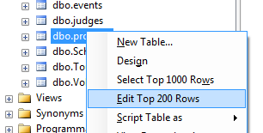

This will allow you to edit the “ProblemName” column in the “dbo.problem” SQL Server table. It should look like the following:

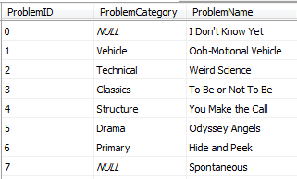

### Changing the Amount Charged for Coaches Training

To change the amount charged for Coaches Training, edit the row in the dbo.events table where the EventName is “Coaches’ Training”. It should look like the following:



Note that there may be additional columns in the table and you may need to scroll right to see all of the columns.

### Adding or Removing References to the Coaches’ Handbook

If you wish to include a link to the latest Coaches’ Handbook from the Virginia state website in the registration e-mail and on the final page of registration, then fill in the Value field with the URL pointing to the Coaches’ Handbook in the row within the config table where the Name is “CoachesHandbookURL”. It should look similar to the following:



If you remove this link altogether, the entire reference to the Coaches’ Handbook will be removed from the e-mail and on the final page of registration.

### Displaying whether Coordinators Pay the Coaches Training Registration Fee

If you wish to display a message stating that “School Coordinators do not pay the Coaches Training Registration Fee” on both pages of registration and in the e-mail sent upon success, then set the Value field to “True” in the row within the config table where the Name is “CoordinatorsDoNotPayCoachesTrainingRegistrationFee”. It should look similar to the following:



### Accessing Coaches Training Registration

You can access the registration page at:

* <http://www.novanorth.org/registration/CoachesTrainingRegistration>

## Judges Registration

### Accessing Judges Registration

You can access the registration page at:

* <http://www.novanorth.org/registration/JudgesRegistration>

## Tournament Registration

### Accessing Tournament Registration

You can access the registration page at:

* <http://www.novanorth.org/registration/TournamentRegistration>